Apache Networks is now offering fixed wireless broadband service in the Albertson’s area
One time install fee = $87.00 - Up to 50’ cable run. (No install fee with 3 year contract)
- Minimum 12 month contract.
- All services include Wi-Fi.
- First month of service is free.
- Free cancellation within 30 days with full refund if necessary.
Broadband rates consist of the following:
Residential:
5Mb Down / 2.5Mb Up $49.00 per Month ___
10Mb Down / 5Mb Up $79.00 per Month ___
Business:
20Mb Down / 10Mb up $159.00 per Month ___
Static Public IP = $15.00 per Month ___
The broadband speed will be dependent on the signal quality determined upon a site survey. We have an estimated coverage map to help determine if the customer is in the coverage area. This coverage map does not take into account signal degradation due to trees, thus a site survey will be needed to determine whether or not service can be offered and what speed can be achieved.
Please see coverage map to see if you are in a potential service area.

Name:________________________________________________________________
Address:______________________________________________________________
Contact number:_______________________________________________________
Signature_________________________________________________Date:________

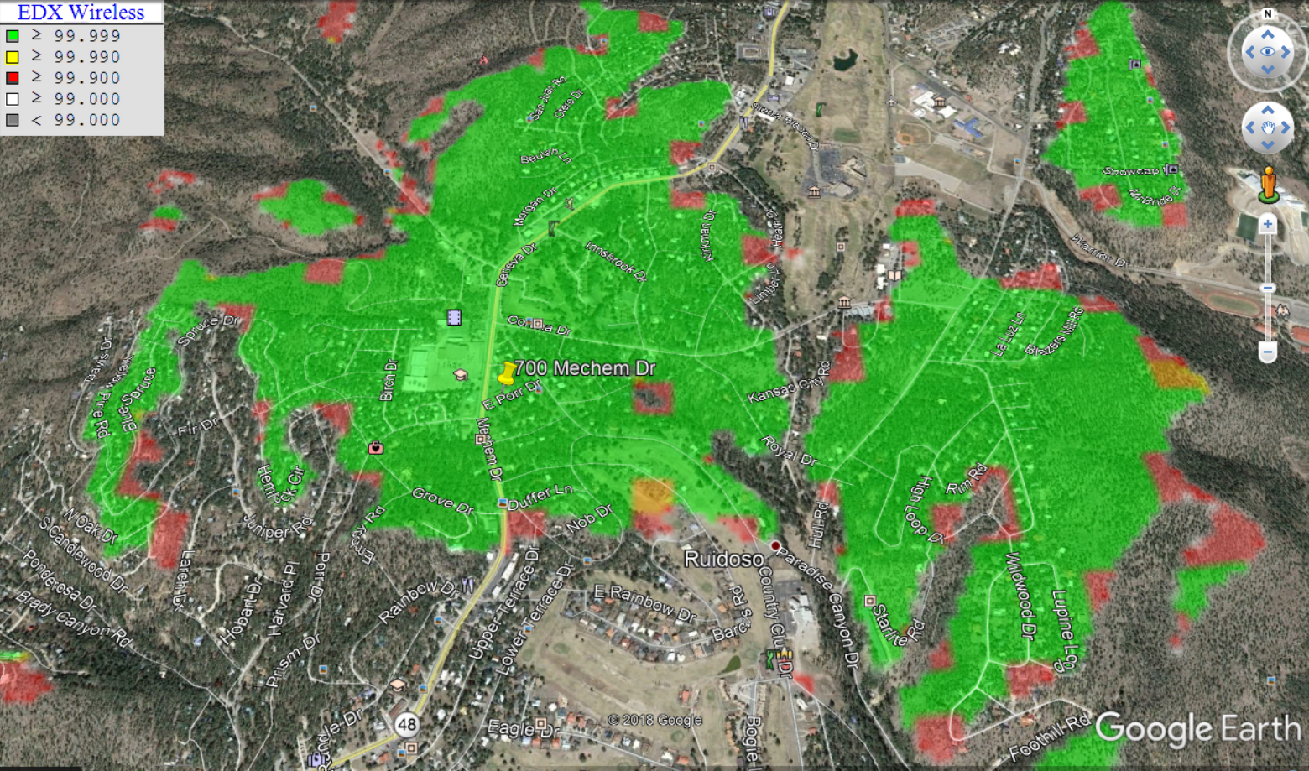

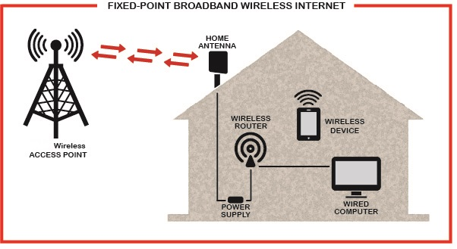
For details please call 575-464-4039 or visit apachenetworks.net

